Uploading Assignments in Moodle from Google Drive

- Click on the white paper icon with the plus sign.

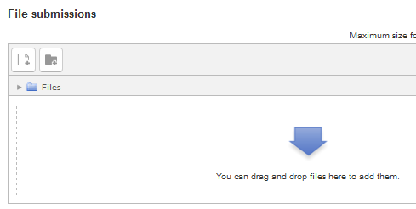

- In the “file picker” window that appears next, click on “Google Drive” in the left column.
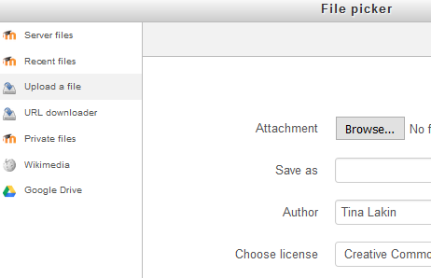

- Next you will see a blue “Log in to your account” button appear in the middle of the file picker window. You will need to click on that and then log in to your Google Drive account. Once you do, you should be able to see all of the documents in your Google Drive account.

- Double-click on the document that you want to upload. Next, a window will appear displaying your document and the “Select this file” button. Make sure the name of your file appears in the “Save as” field and click on the “Select this file” button.
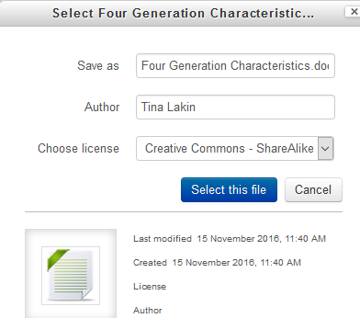
- YOU ARE NOT DONE YET. (Almost!) Next you will be taken back to the original file submission screen where you will again make sure your document is showing and then click on “save changes”.
